lgbfgfTds k/LIff
sIffM ^ ljifoM ul0ft

ljBfyL{sf] gfdM ===============================================================================================================
ljBfnosf] gfdM ================================================================================= lhNnfM ==========================
tkfO{FM s]6f s]6L :yfgLo txM=================================

!= tn lbOPsf] sf]0f slt l8u|Lsf] 5 < How many degrees is the angle shown below?
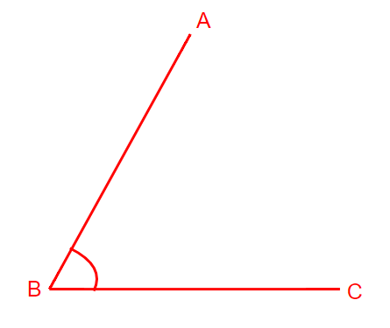
-s_ 30º
-v_ 45º
-u_ 60º
-3_ 75º

@= sf]0fsf] k|sf/;Fu sf]0f hf]8f ldnfpg'xf];\ . Match the figure with the type of angle.
-s_ clwssf]0f (obtuse angle)  -v_ Go"gsf]0f (acute angle)  -u_ ;dsf]0f (right angle) | 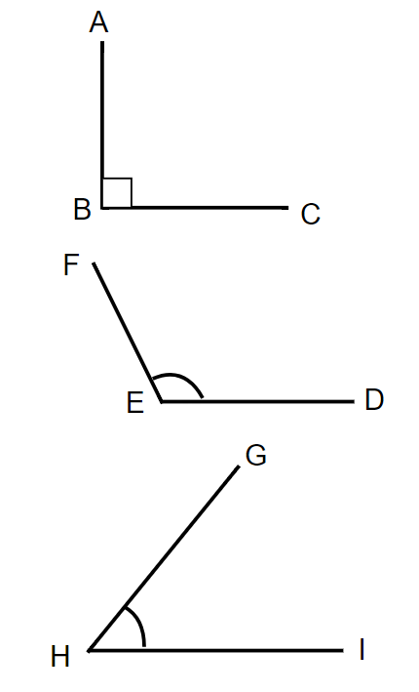
#= lbOPsf] cfotsf] kl/ldlt / If]qkmn kQf nufpg'xf];\ . Find the perimeter and area of the given rectangle.
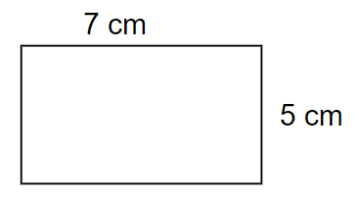

kl/ldlt (perimeter) = ……………………………………………………………….. [1]

If]qkmn (area) = ………………………………………………………………… [1]

$= *$%^& nfO{ cIf/df n]Vbf s;/L n]lvG5 < l7s lrGx -✓_ nufpg'xf];\ . How is 84567 written in words? Mark with a tick mark (). [1]

-s_ cf7 nfv rf/ xhf/ kfFr ;o ;t;7\7L (Eight lakhs four thousands five hundred and sixty seven)
-v_ rf}/f;L nfv kfFr ;o ;t;7\7L (Eighty four lakhs five thundred and sixty seven)

-u_ rf}/f;L xhf/ kfFr ;o ;t;7\7L (Eight four thousands five hundred and sixty seven)

-3_ cf7 xhf/ k}rfln; ;o ;t;7\7L (Eight thousands forty five hundred and sixty seven)

%= #( s:tf] ;ª\Vof xf] < What type of number is 39? [1]
-s_ ?9 ;ª\Vof (prime number)
-v_ ;+o'St ;ª\Vof (composite number)
-u_ hf]/ ;ª\Vof (even number)
-3_ bzdna ;ª\Vof (decimal number)

^= 45 + 2(6 - 2) = ? [1]
-s_ 49
-v_ 50
-u_ 53
-3_ 55

&= $2\frac{1}{5}$ s:tf] ;ª\Vof xf] < What type of number is $2\frac{1}{5}$? [1]
-s_ ld>Lt ;ª\Vof (mixed fraction numbers)
-v_ pko'St leGg ;ª\Vof (proper fraction numbers)
-u_ cg'ko'St leGg ;ª\Vof (improper fraction numbers)
-3_ ;dt"No leGg ;ª\Vof (equivalent fraction numbers)

*= 0.15 nfO{ leGgdf abNbf slt x'G5 < how much we get when converting 0.15 in fraction?
-s_ $\frac{1}{5}$
-v_ $\frac{1}{15}$
-u_ $\frac{15}{10}$
-3_ $\frac{15}{100}$
(=s= 2 lsnf]u|fd 300 u|fdnfO{ u|fddf abNg'xf];\ . Convert 2 kg and 300 grams to grams.

v= @ lsnf]ld6/ %)) ld6/nfO{ ld6/df abNg'xf];\ . Convert 2 km and 500 metres to metres.

!)= Pp6f cfotsf/ 6\ofª\sLsf] nDafO 5 m, rf}8fO 4 m / prfO 3 m 5 eg] ;f] 6\ofª\sLsf] cfotg kQf nufpg'xf];\ . If the length of a rectangular tank is 5 m, width 4 m and height 3m, find the volume of the tank. [1]
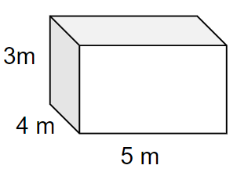

!!= /fdn] cfO{taf/ @) lsnf]ld6/ %)) ld6/ lx8\of] / ;f]daf/ !% lsnf]ld6/ &)) ld6/ lx8\of] eg] hDdf slt b"/L lx8\of] < kQf nufpg'xf];\ . If Ram walked 20 km and 500 m on Sunday and 15 km and 700 m on Monday, how much distance did he walk in total? Find out. [1]

!@= x + 3 = 9 df rn / crn /fzL s'g s'g x'g < what are the variable and constant in x + 3 = 9 ? [2]

rn /fzL variable M ================

crn /fzL constant M ===============

!#= ;/n ug'{xf];\ . Simplify. [1]
3x + 2y - x + 4y

!$= ;dLs/0f xn ug{'xf];\ . Solve the equation. [1]
2x + 1 = 7

