lgbfgfTds k/LIff
sIffM & ljifoM ul0ft

ljBfyL{sf] gfdM ===============================================================================================================
ljBfnosf] gfdM ================================================================================= lhNnfM ==========================
tkfO{FM s]6f s]6L :yfgLo txM=================================

!= sf]0fsf] k|sf/ x]/L vfln7fpF eg'{xf];\ . fill in the gaps with appropriate type of angle (1x4)
-s_ 7Ls 90º sf] sf]0fnfO{ ======================================== elgG5 . The angle of exactly 90º is called ………………..
-v_ 90º eGbf ;fgf] / 0º eGbf 7"nf] sf]0fnfO{ ======================================== elgG5 . The angle smaller than 90º and greater than 0º is called ………………
-u_ 90º eGbf 7"nf] 180º eGbf ;fgf] sf]0fnfO{ ======================================== elgG5 . The angle greater than 90º and smaller than 180º is called …………………….
-3_ 7Ls 180º sf] sf]0fnfO{ ======================================== elgG5 . The angle of exactly 180º is called ………………

@= sDkf;sf] k|of]u u/L 60 l8u|Lsf] sf]0f lvRg'xf];\ . Construct an angle of 60º by using compass.

#= tnsf] juf{lªst sfuhdf b'O{ j6f ;dfgfGt/ /]vfx? lvRg'xf];\ . Draw two parallel lines in the given graph paper. (1)

$= tLgcf]6} e'hfx? a/fa/ ePsf] lqe'hnfO{ s] elgG5 < l7s lrGx -_ nufpg'xf];\ . What is the name for a triangle with all three equal sides? Mark with a tick mark (). [1]
-s_ ;dlåafx' lqe'h Isosceles triangle
-v_ ;dafx' lqe'h equilateral triangle
-u_ lj;dafx' lqe'h Scalene triangle

%= tnsf] if8d'vfsf] cfotg slt x'G5 < what is the volume of a given cuboid? [1]
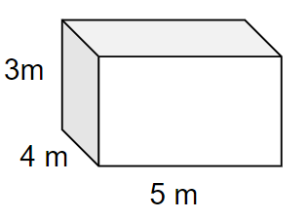
-s 12 ld6/ (12 meter)
-v_ 12 ju{ld6/ (12 square meter)
-u_ 60 3gld6/ (60 cube meter)
-3_ 60 ju{ld6/ (60 square meter)

^= Pp6f ;8d'vfsf s'gf, lsgf/f / ;txsf] ;DaGw s] x'G5 < What is the relationship between the vertices, edges and faces of a cuboid?
-s_ F+V–E = 2
-v_ F−V–E = 2
-u_ F−V+E = 2
-3_ F+V+E = 2

&= 80 ÷ [10 − 2(4 − 3)] ?
-s_ 6
-v_ 10
-u_ 16
-3_ 40

*= 24 sf ?9 u'0fgv08 s'g x'g\ < Which are the prime factors of 24?
-s_ 3 × 8
-v_ 2 × 12
-u_ 6 × 3 × 2
-3_ 2 × 2 × 2 × 3

(= 12 / 10 sf] n; slt x'G5 < What is the LCM of 12 and 10?
-s_ 120
-v_ 120
-u_ 120
-u_ 12

!)= ;/n ug'{xf];\ Simplify: $\frac{3}{4}+\frac{5}{6}$ (2)

!!= ? 200 df lsg]sf] lstfj ? 170 a]Rbf slt gfkmf jf gf]S;fg x'G5 < What is the profit or loss when a book is bought for Rs. 200 and sold for Rs. 170? (2)

!@= rf/cf]6f sndsf] d"No ? 32 k5{ eg] 8 cf]6f sndsf] d"No slt k5{ < If the cost of four pens is Rs. 32. What is the cost of 8 such pens? (2)

!#= ;/n ug'xf];\ SimplifyM 5x − 2y + 7x − 2y − 3x (2)

!$= ;lds/0f 3x + 5 = 9 xn ug'{xf];\ . Solve the equation 3x + 5 = 9. (1)

!%= ljGb' A sf] lgb]{zfª\s slt x'G5 < What is the coordinate of point A? (1)
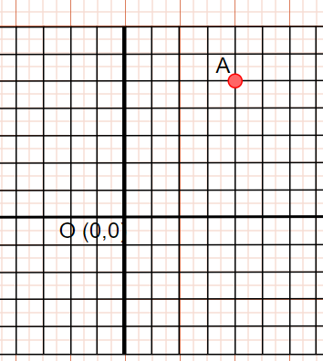

===============================================

!^= tflnsfdf lstfjsf] ;ª\Vof lbOPsf] 5 . In the given table, number of different books is given. (4)
lstfjsf] gfd (Book’s name) | ;ª\Vof  (number)
g]kfnL Nepali | 20
ul0ft Math | 30
c+u|]hL English | 15
lj1fg Science | 25
pk/f]St tYofª\snfO{ tnsf] juf{ª\lst sfuhdf jf/u|fkm lvRg'xf];\ . Make a bar graph to show the above data.

!&= u'0fg ug'{xf];\ . Multiply. (2)
(x + y) (2x - y)

